In this lab we will create an Artifact Repository to store the the image and then we will use it in further labs for this module. Once created we will also upload an image to it.

On GCP, search Artifact and open Artifact Registry

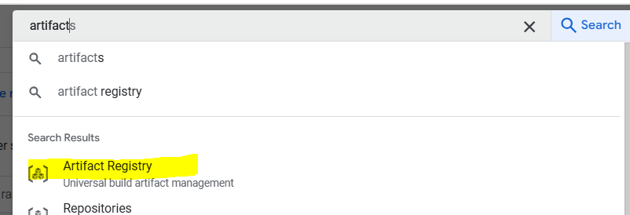

Give it a name “my-repo”, keep Format as Docker and Mode as Standard ( Remote and Virtual are used mainly for hybrid scenarios or when we want to merge various repositories into a single one.)

Select your region and keep rest options as default

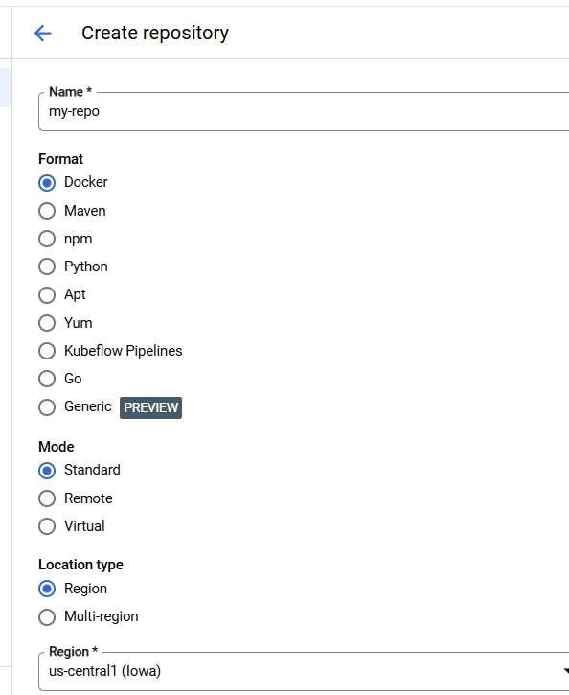

Click Create

Extract cart baseline folder and copy cart folder from it to ReadIt app folder in the c drive

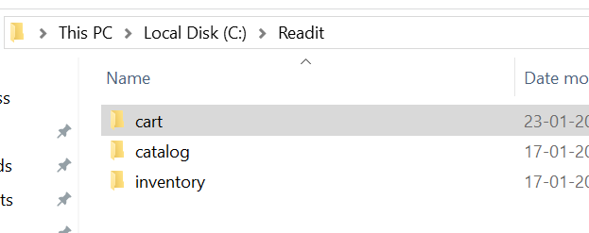

Open cart folder in VScode from readit app and if see pop up to add required debug, click yes

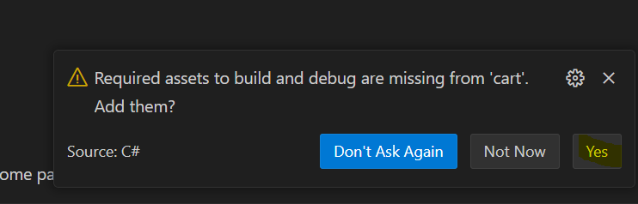

Open DockerFile and go throught it and the Docker file specifies how exactly we want to build the Docker image for publishing.

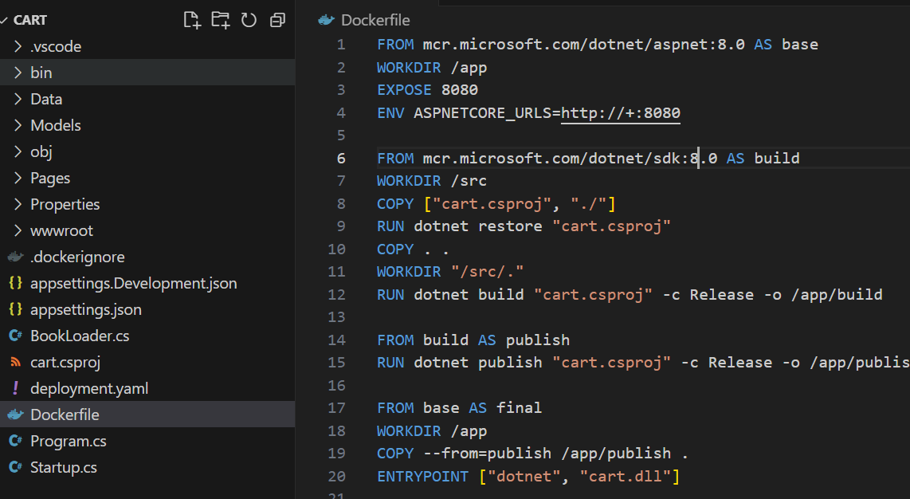

Hit f5 to ensure the code is running locally to our machine and this should open Cart webpage on browser

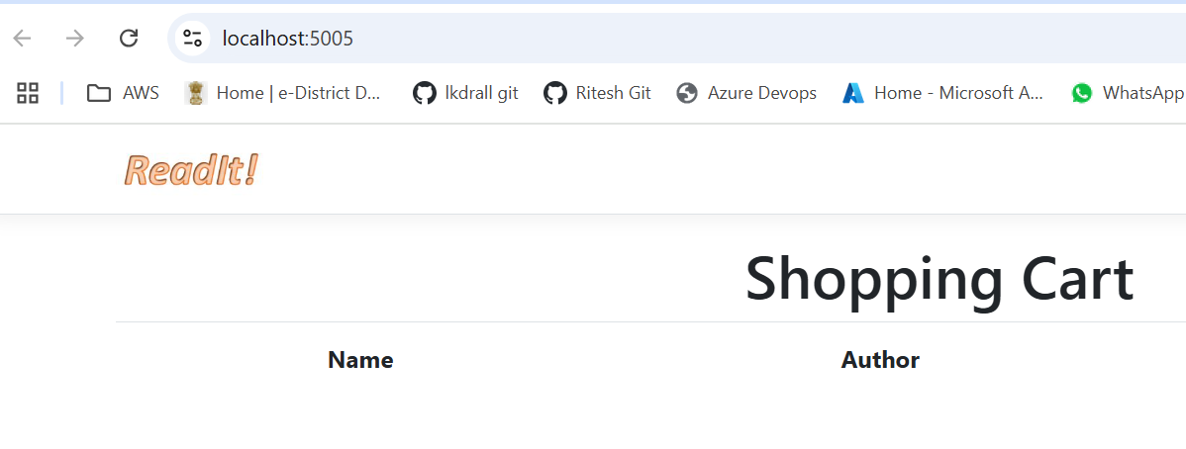

Now we need to build the docker image from the code and push the image to repository we created. Also we do not need to install any local software for docker

Now first we will check our repository from vscode, for this run below command in vscode and it should list our repository

gcloud artifacts repositories list

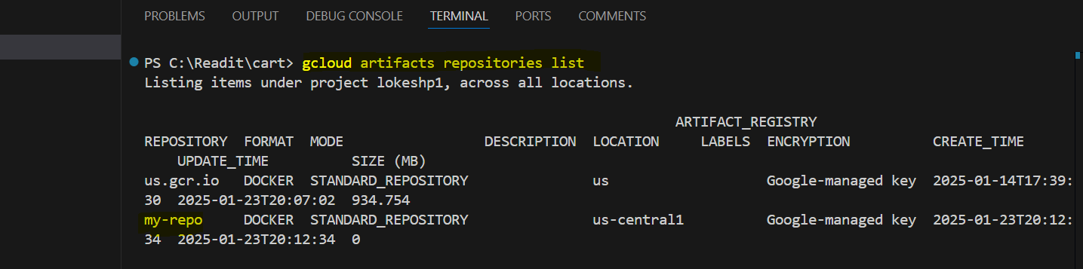

Now go to GCP console, open my-repo registry and click setup Instructions, and copy only second line from there

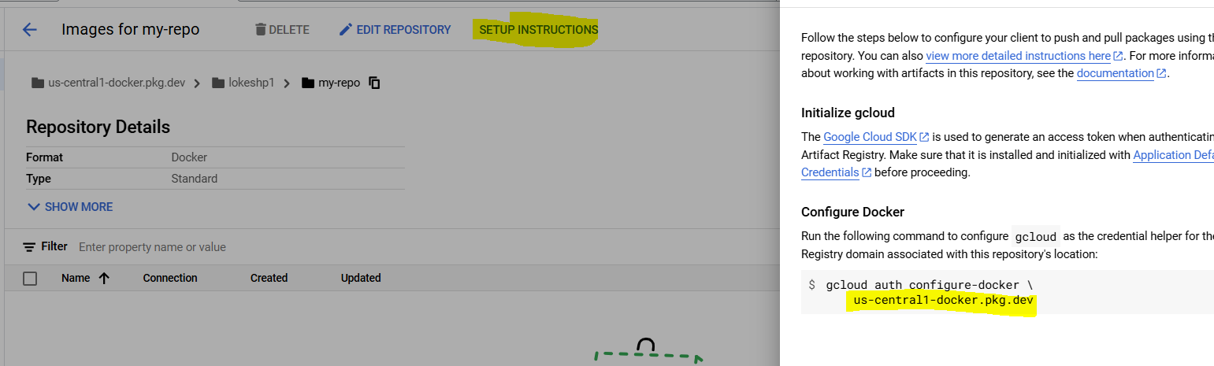

In below command, update the details as shown after. (Try to keep the region as us-central1 only as it have best resources available)

gcloud builds submit --region=us-central1 --tag <ARTIFACT_REGISTRY_URL>/<PROJECT_ID>/my-repo/cart:v1

gcloud builds submit --region=us-central1 --tag us-central1-docker.pkg.dev/lokeshp1/my-repo/cart:v1

(Here make sure to use correct details for project id and repo name. In this command :v1 is the tag which we are going to use for the image and which can help to identify the image and its versions)

Now run the command in vscode

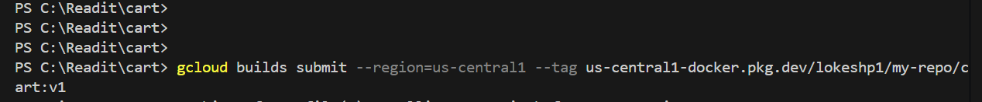

Once completed, vscode should give success message

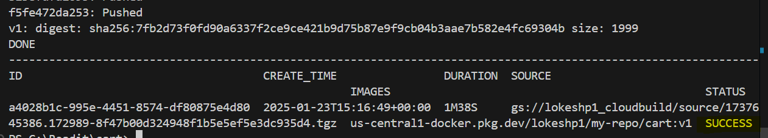

Now go to GCP console again and refresh page, under my-repo page, now it should show our docker image with cart1 name and docker symbol

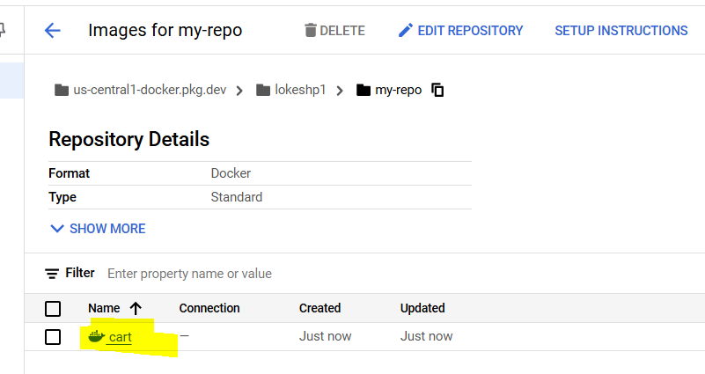

Open the image, and check the tag for version number which we gave

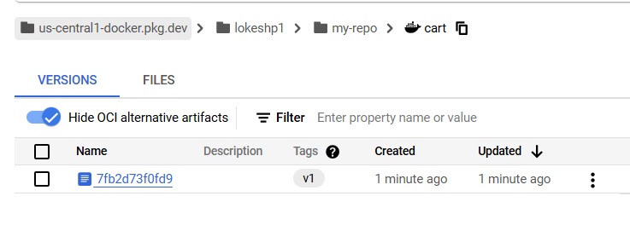

Now our docker image is ready to use, note image is build up of the code like in this case we are using cart code, and when we will use this image, it will directly have the code running which we will see in further sessions.